6.1.1 INCREMENTED DATE
ALGORITHM
Step 1: Start
Step 2: Input day, month, year
Step 3: If year ≤ 0 → Print "Invalid Date" and Stop
Step 4: If month < 1 OR month > 12 → Print "Invalid Date" and Stop
Step 5: Determine number of days in the month:
- If month = 1,3,5,7,8,10,12 → days = 31
- If month = 4,6,9,11 → days = 30
- If month = 2:
  - If leap year → days = 29
  - Else → days = 28
(Leap year condition:
year % 400 == 0 OR
(year % 4 == 0 AND year % 100 ≠ 0))
Step 6: If day < 1 OR day > days → Print "Invalid Date" and Stop
Step 7: If day < days
day = day + 1
Step 8: Else (day == days)
- day = 1
- If month == 12
month = 1
year = year + 1
- Else
month = month + 1
Step 9: Print date in DD-MM-YYYY format
Step 10: Stop

FLOWCHART
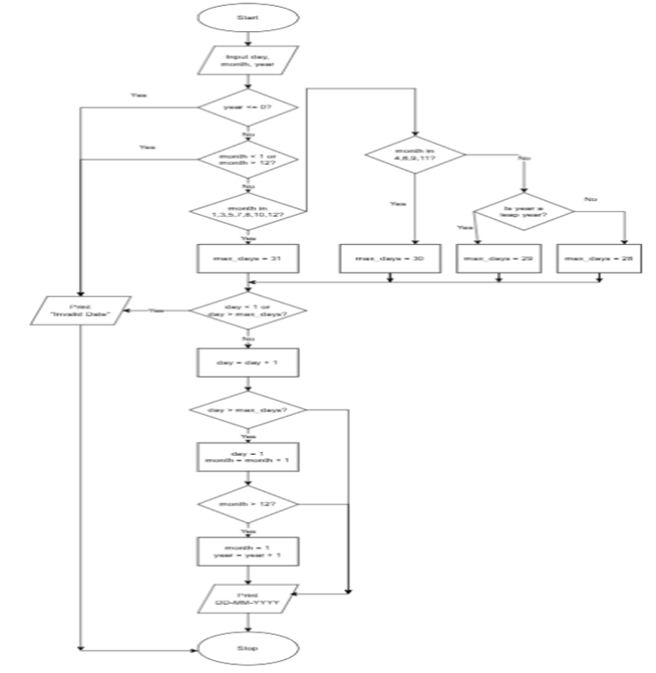
PROGRAM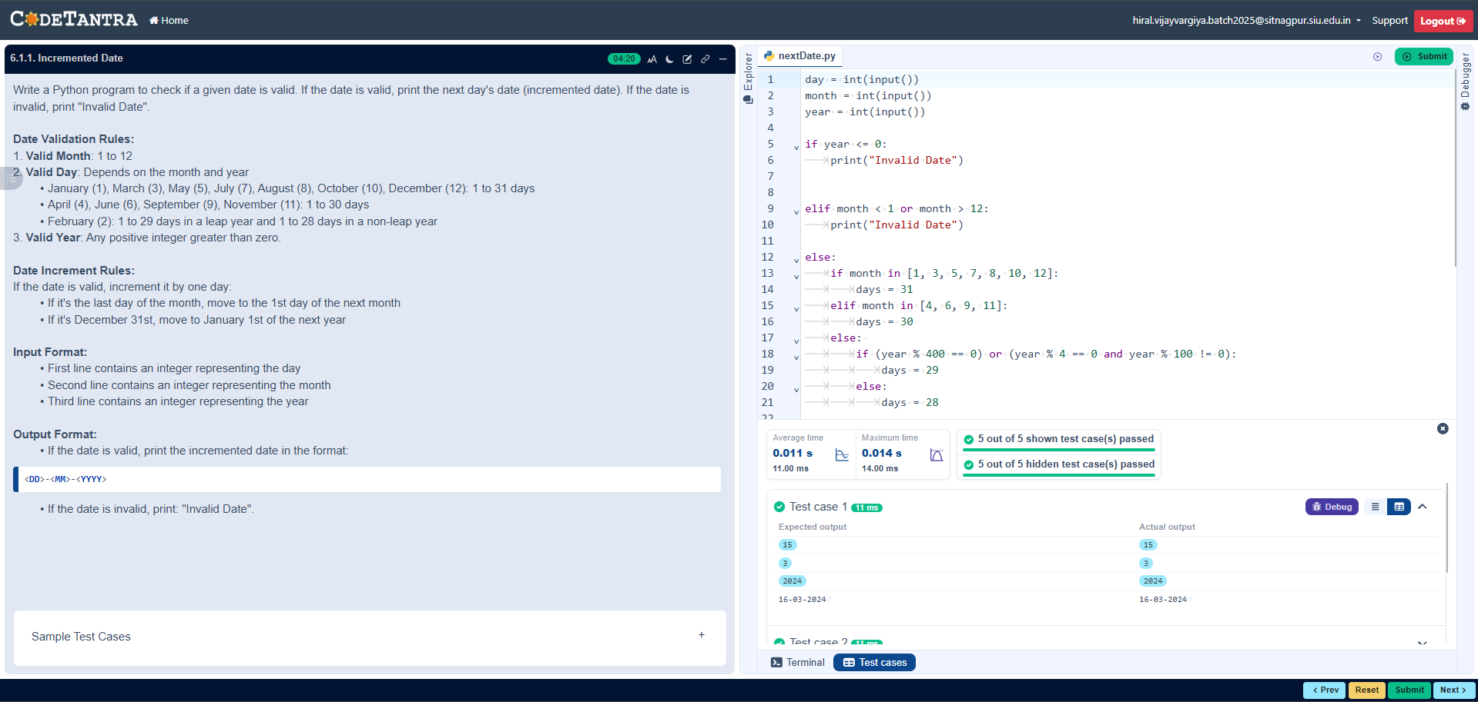

6.1.2 FACTORIAL OF A NUMBER
ALGORITHM
Step 1: Start
Step 2: Input integer n
Step 3: If n < 0
Print "Invalid Input" and Stop
Step 4: Set fact ← 1
Step 5: Set i ← 1
Step 6: While i ≤ n
fact ← fact × i
i ← i + 1
Step 7: Print fact
Step 8: Stop
FLOWCHART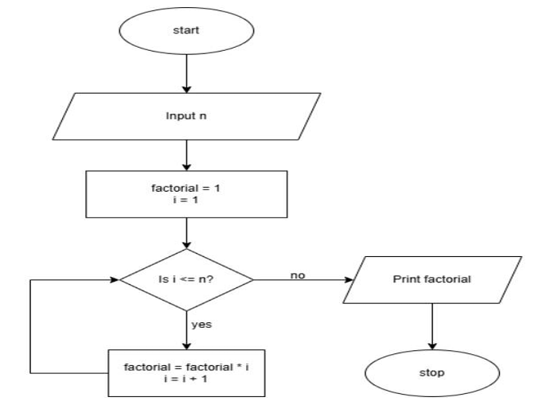
PROGRAM
